**Bromham Village Show Entry Form**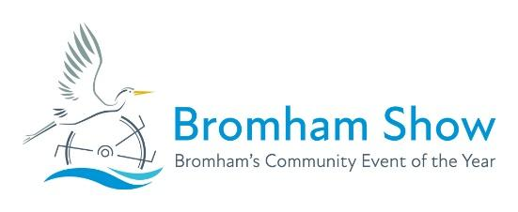

*Sunday 12th July 2026*

Exhibitors may only enter **3** exhibits in each class

All children may enter their own unaided work in the adult classes.

|  |  |  |  |  |  |
| --- | --- | --- | --- | --- | --- |
| **Name** | **Age**  **(if under 16)** | **Class Number** | **Description of Entry** | **Size**  **(of craft or art)** | **Fee**  **50p per Adult item**  **20p per Child item** |
|  |  |  |  |  |  |
|  |  |  |  |  |  |
|  |  |  |  |  |  |
|  |  |  |  |  |  |
|  |  |  |  |  |  |
|  |  |  |  |  |  |
|  |  |  |  |  |  |
|  |  |  |  |  |  |
|  |  |  |  |  |  |
|  |  |  |  |  |  |
|  |  |  |  |  |  |
|  |  |  |  |  |  |
|  |  |  |  |  |  |
|  |  |  |  |  |  |
|  |  |  |  |  |  |
|  |  |  |  |  |  |
|  |  |  |  |  |  |
|  |  |  |  |  |  |
|  |  |  |  |  |  |
|  |  |  |  |  |  |
|  |  |  |  | **Total Fee**  **(enclosed/**  **bank transfer)** |  |

I / We agree to abide by the rules of the show Signed : _________________________

Name : _____________________________ Address : ____________________________________________________

Tel no. : _______________________ Email : ______________________________________ Postcode : ___________________

Please return this form to the collection boxes at One Stop or Welcome Co-op OR

Email to [exhibits@bromhamshow.com](mailto:exhibits@bromhamshow.com) with your bank transfer

Entries closing date: 5pm Friday 10th July, 2026

Photocopies of this form are accepted, or you can download copies from the Bromham Show website.

Bank details: National Westminster Bank, 81 High Street, Bedford, MK41 1YN, Sort Code 60-02-13 Account Number 51328267