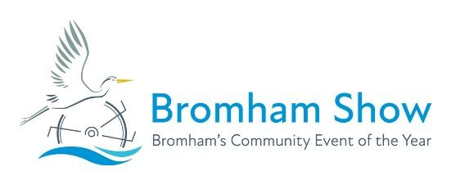
Bromham Village Show Entry Form
Sunday 12th July, 2026
Exhibitors may only enter 3 exhibits in each class
All children may enter their own unaided work in the adult classes.

Name | Age  (if under 16) | Class Number | Description of Entry | Size  (of craft or art) | Fee  50p per Adult item  20p per Child item
Total Fee
(enclosed/
bank transfer)
I / We agree to abide by the rules of the show Signed : _________________________
Name : _____________________________ Address : ____________________________________________________
Tel no. : _______________________ Email : ______________________________________ Postcode : ___________________
Please return this form together with payment (or bank transfer details) to the collection boxes at One Stop or Welcome Co-op
Entries closing date: 5pm Friday 10th July, 2026
Photocopies of this form are accepted, or you can download copies from the Bromham Show website.
Bank details: National Westminster Bank, 81 High Street, Bedford, MK41 1YN, Sort Code 60-02-13 Account Number 51328267

